Revision - Resistant Materials 2004.

The theme for your mock exam is Garden Equipment. The pre-release sheet gives you an indication of the types of products that you will get asked questions about. This could include Seating and Tables, Plant trays, Garden Hand Tools, Wheelbarrows and Garden Trolleys. The following are the areas which will appear in the exam.

- Construction techniques - How the products could be assembled.
- Materials and finishes - Names of suitable materials and the type of finish that could be applied.
- Industrial practice - Use of jigs/templates. Plastic forming techniques (Injection moulding etc).
- Packaging - The types of materials used. Design considerations.
- Analysis and Evaluation - Critically discussing the advantages/disadvantages of a given product.
- Ergonomics - What and how human sizes will affect the design of garden equipment.
- CAD/CAM - Use in producing garden equipment or its components.
Advantages/disadvantages etc.
- Design requirements - Producing designs for a piece of garden equipment with a given
specification.
- Environmental issues - Use of materials. Recycling etc.
- Health and safety - Issues to do with the production of a desk and its use.

The vast majority of questions on your exam paper will be to do with this theme; however, there will also be some general Design and Technology questions which do not relate to the theme.

Following are some questions you could get asked. Work through these questions as part of your revision. Questions you cannot answer, find out the answers to!

- Below is a picture of a wooden garden chair.
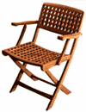

  - The chair is made from Teak. Give 2 reasons why this material has been chosen.

  - Name another suitable hardwood the chair could be made from instead.

  - Why would a softwood not be as suitable as a hardwood for this item?

  - The chair is supplied without a finish. What does this mean?

  - Give 2 reasons why a finish might be needed on the chair.

  - Name 2 suitable finishes that could be applied to the chair.

  - The chair could be sold as a ‘flat pack’. What does this mean?

  - What are the advantages of flat pack furniture to the following:
The manufacturer -

The retailer -

The consumer -

- Below is a picture of part of a garden table. It shows a support for the table top where it will join to a leg using 2 screws. The manufacturer is going to make the table in batches of 500.
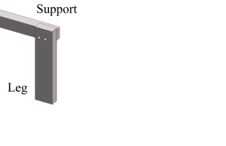

  - Give 2 reasons why the manufacturer would use a jig to mark out and drill the screw holes.

  - Using notes and sketches, design a jig which the manufacturer could use to mark out and drill the holes.

- What is meant by the following terms:
  - Anthropometrics
  - Ergonomics
  - Aesthetics

- Seed trays were traditionally made from wood. Today they are usually made from plastic. A drawing of a tray is shown below.
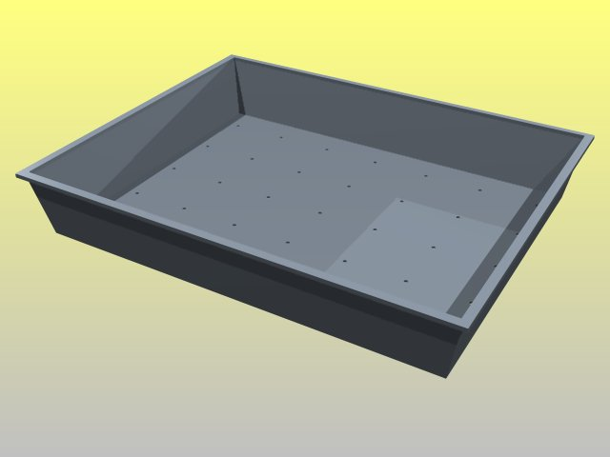

  - Give 2 reasons why plastic is used instead of wood.

  - Name 2 methods of manufacturing the tray shown above out of plastic, and name a suitable plastic for each process.
Process Material
Process Material
  - When the tray is full, it was found to twist and break. Sketch below 2 ways how the tray could be strengthened.

- List 5 pieces of anthropometric data a designer would use when designing a garden chair.

- Below is a picture of a trolley suitable for transporting garden tools around the garden.
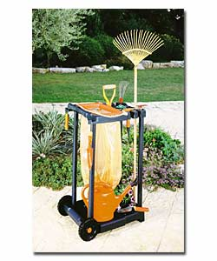

  - Name a suitable plastic for making the uprights
Reason?
  - The plastic wheels are to be made by injection moulding. Use notes and sketches to describe the process of injection moulding.

- Explain how a manufacturer of wooden garden furniture can make the product environmentally friendly in the following areas:
Choice of materials

Type of finish applied

The manufacturing processes used

- Explain what this symbol means.


- A manufacturer is going to add turned aluminium decoration to a range of garden furniture it sells. These components are going to be made on a CNC lathe.
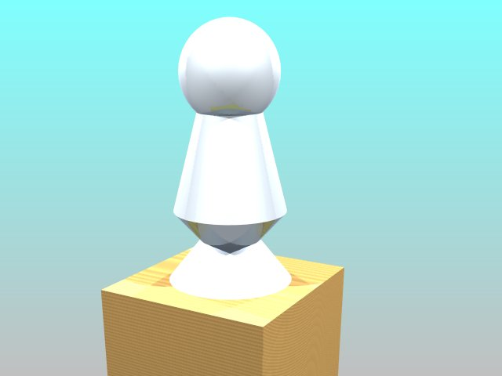

i) What are 2 advantages of using CAM to make the components?

ii) What are 2 disadvantages of using CAM to make the components?

- Safety in the workshop is very important. List 6 safety points that a manufacturer should consider to ensure that it provides a safe environment for its workers.

- In the space below, produce 2 designs for a garden trolley that will hold a spade, garden fork, a bag for rubbish and a shelf to carry small plants. How the product couls be used by the elderly should also be considered. On plain paper, produce a detailed, annotated drawing of your final designs.

TIPS FOR THE EXAM.
Look at existing garden equipment (Argos etc) and try and work out what materials and fixings have been used and why.
Revise thoroughly; use books, ask in school for help, and use the Departments revision website www.the-warren.org
Go to the exam equipped – take pens, pencils, ruler etc, and also coloured pencils.
Plan your time - spend about 1 minute per mark.
Don’t panic!!! Good luck!!!
TIPS FOR THE EXAM.
Look at existing desks (Argos etc) and try and work out what materials and fixings have been used and why.
Revise thoroughly; use books, ask in school for help, and use the Departments revision website www.the-warren.org
Go to the exam equipped – take pens, pencils, ruler etc, and also coloured pencils.
Plan your time - spend about 1 minute per mark.
Don’t panic!!! Good luck!!!

