Product Design Project Guide

The Project - Night Light

Why are you doing it?

Manufacturers will always be looking to improve their products to increase sales or launching a new product where they identify a gap in the market. To do this, the manufacturer will turn to the PRODUCT DESIGNER

You are now a PRODUCT DESIGNER

You must know your TARGET MARKET
You must know that you are designing for a commercial MARKET
You must know that you are designing for a commercial MANUFACTURER
You must know that you are designing for a commercial NEED

Product Designers will develop a DESIGN PORTFOLIO – this is similar to your own coursework folder where you will show the research you will gather and your different ideas that will lead to the final solution and a PROTOTYPE of the new product.

Design Folder

Your folder will have the following main sections. You will also need to keep track of your progress as you will have strict deadlines to keep to, so you will be given a progress sheet to keep with your work.

Sections:
Front Sheet
Contents page (Completed at end of the project)
Introduction, Design Problem, Brief and Task Analysis
Research
Existing Products, Product Analysis, Theme/Inspiration (Image/Mood board), Technology/Processes/Materials, Market Research (Primary)
Research Evaluation
Specifications
Initial Ideas
Sketch Modelling
Development
Modelling CAD (ProDesktop)
Making
Testing
Evaluating

⇧ CTRL & CLICK ON ARROW, WILL BRING YOU BACK TO THIS PAGE

What will you be making?

The purpose of the project is for you to show the examiner that you understand the DESIGN PROCESS and have learnt a range of designing and making skills necessary to be a product designer.

You will produce the following:
- A PROTOTYPE Night Light – Vacuum formed with a real working light.
- PACKAGING for your night light.
- INSTRUCTION SHEET
- MARKETING MATERIAL – Poster and pictures in a catalogue or www.

Front Sheet 

This will be the front cover that will identify you and the project.
This must have:

YOUR FULL NAME
YOUR CANDIDATE NUMBER
NAME OF THE PROJECT
NAME OF THE SCHOOL – WARREN COMPREHENSIVE
SCHOOL NUMBER – 12111
YEAR OF THE WORK – 2005
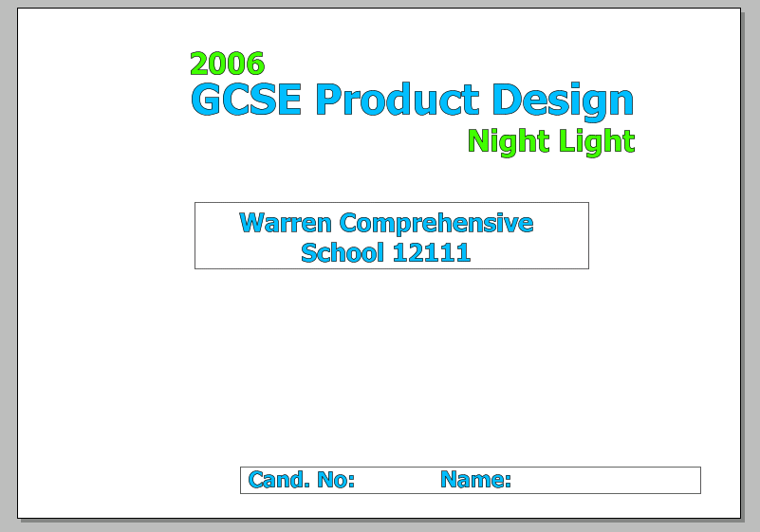

⇧

Introduction - Design Problem, Brief and
Task Analysis 

This is the first page and you will start your project by writing an INTRODUCTION explaining the DESIGN PROBLEM

Introduction - Design Problem 
You must introduce your project here. First write about the problem e.g. you will need to think about what your CLIENT wants you to do and why, when designing a night light for them:

- You will need to explain in your own words, and write about why they need you to design a new night light for them (Redesigning, New product / New range etc.)
- Explain why people need a night light – child’s bedroom, lighting the top of the stairs etc. is it to make children feel safe at night?
- How safe must it be?
- How do they want it powered? (Battery or mains)

Now write about these points in your own way. Include examples from your own experience. A good way to start is imagine the Night Lights had just been thought of and describe their benefit to people.

Brief 
This is where you write a short statement of intent. – ‘I am going to design and make a prototype night light and related merchandising materials for ……………company who will be marketing the new product in their stores’.

Task Analysis 
Know and plan what jobs you need to do.
Write the name of the project at the top of the page.
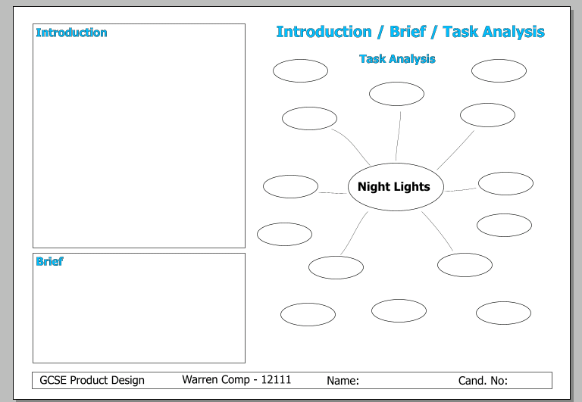
Write keyword questions in the other boxes.
- Who is it for?
- Who will use it?
- Other products on sale
- Product Analysis
- How much will it cost to make the real product?
- How much will a shop sell it for?
- Where will it be used?
- Battery or mains electricity?
- What theme will it be based on?
- What does it do? – features etc.
- How long will it take to make the products?
- How will the prototype be made?
- What are night lights bought in the shops made from?
- What skills do you need to be able to make it?

Add extra sections to the chart with things you need to know if you wish. 

Research 

Existing Products 
Stick a picture of a product that is already in the shops in each box. Get these pictures from the companies websites. e.g.
www.argos.co.uk www.ikea.co.uk www.index.co.uk
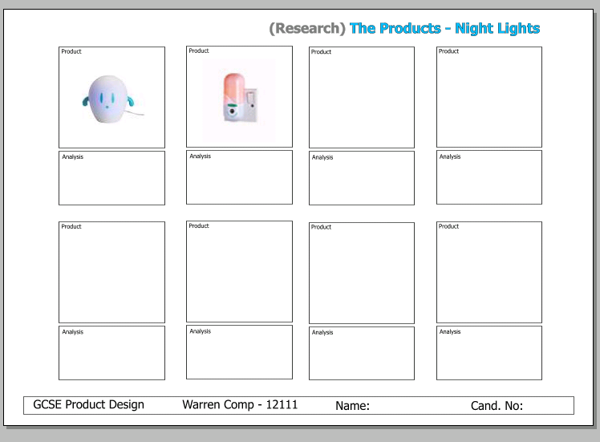
www.diy.com www.mothercare.com www.toysrus.co.uk
Write three good points and three bad points for light.
Good points could be:
- price - affordable for the client,
- style - children will like it
- colour – attractive
- easy to store or portable
Bad points could be :
- too expensive, too cheap
- unsafe
- not very colourful
- mains operated - safety
- not portable
You will be writing a summary of your findings on a Research Evaluation sheet later on. 

Research – Product Analysis
Night Lights & Packaging 

For this section, you will need to carry out a full PRODUCT ANALYSIS of both a night light and some suitable packaging.

An important part of all design projects is product analysis. Product analysis involves looking carefully at existing products and learning things from them. The product analysis guideline below will give you a framework that you can use, for any product. To use this guideline, look at your own product(s), and then answer each question in turn. Some of the headings and questions may not always be relevant to your product and can be left out.

Two sheets have been prepared for you with photographs of a night light and the packaging with the appropriate headings for the Product Analysis criteria.
On your sheet, using the headings, ‘HAND WRITE’ and answer the questions for each section to develop your analysis.

You must also LABEL the photographs identifying the main components.
(You may re-arrange the format to suit your own style).

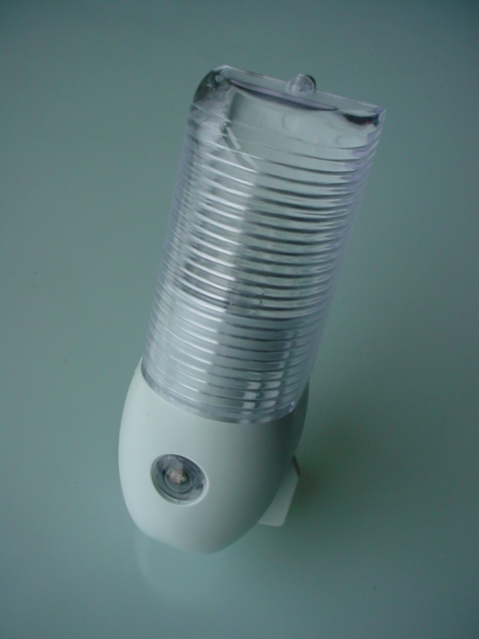
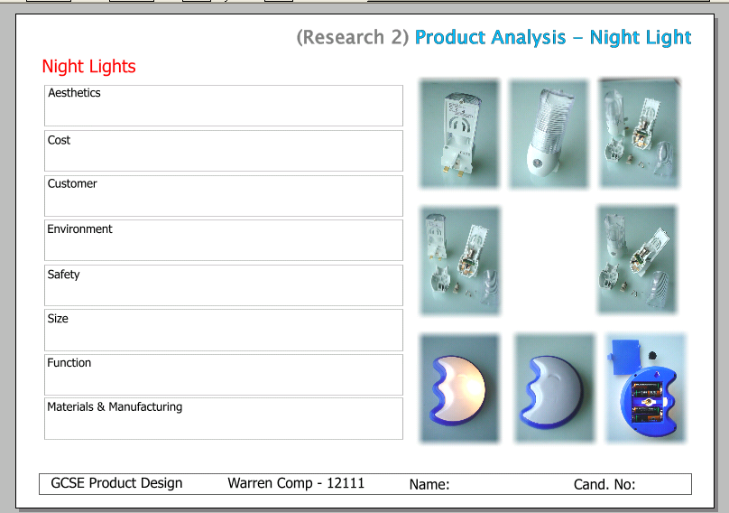
NIGHT LIGHT – Product Analysis

Aesthetics
- Does the product look attractive?
- Does it make good use of colour and texture?
- Does It have a quality finish?
- Where did the designer get his or her inspiration?

Cost
- What is the estimated cost of production? What is the retail cost?
- What is the relationship between the two? Is the product affordable?
- Does It seem good value for money?
- Does the price reflect any social or moral considerations (e.g. Fair Trade)?

Customer
- Who is the product designed for?
- How and where would they use it?
- What impact will it have on the customer’s quality of life?
- Will it add value?
- How is the product promoted to attract its customer?

Environment
- What is the product’s impact on the environment?
- Think about its manufacture, general use, distribution and final disposal when it’s no longer needed.

Safety
- How has the designer considered safety issues when designing the product?
- Think about the way the product is used and how different parts have been joined together.
- Does the product meet recognised safety standards?
Size
- Is the product comfortable to use?
- Are its proportions appropriate for its use?
- If you increased or decreased the product’s scale, would it work or look better?
- To what extent has the designer considered human factors (ergonomics) iii the product’s design?

Function
- How well does the product work?
- Could it be Improved to work better?
- How easy is it to use?

Materials and Manufacturing
- What is the product made from?
- Would another type of material work better?
- What impact could the designer’s choice of material have on the environment? How has the scale of production affected the designer’s choice of material and manufacturing processes?
⇧

PACKAGING – Product Analysis
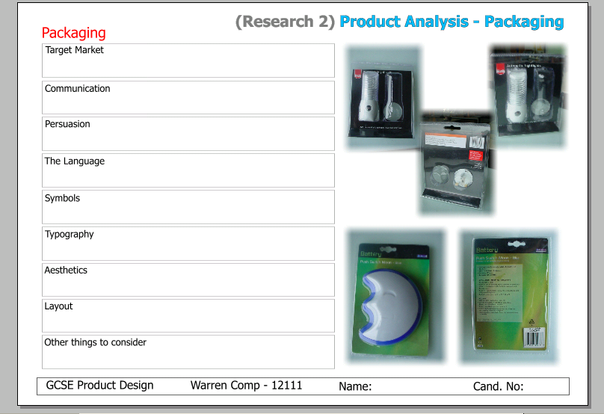

Target Market
- What is the market for the product or service and how do you know?
- Who uses it/buys it?
- Are there any clues in the text/colours/graphics that indicate the target market?
- Are different styles used for different age groups?

Communication
Think about how the information contained on the graphic product is given to the buyer. Is it:
- Overt — this means open or obvious Is it easy to tell from the graphic what the message is?
- Covert – this means hidden (sometimes the message or image is deliberately hidden to make people think deeply about a product). Is the message hidden?
- What Information is required by law for this product?

Persuasion
Graphic products are successful when they attract, create interest, create desire and lead to action (people buying or using the product).
- What convinces people to buy this product/service rather than similar brands or alternatives (Think about the design, the words, the messages.)

The language
- What language and words are used to sell-the product?
- Do they persuade you?
- Are they true/honest?
- Do they use a catchy slogan?
- If so, why?

Symbols
Often Graphic Products use symbols to help sell them.
Symbols are sometimes cartoon characters or things like medals or ribbons which are used to suggest that they are the best.
- Does the graphic product have any symbols associated with It?
- Why are the symbols used
- Is there a company logo or trademark used? If so why?

Typography
- What style of text is used? - Is It Serif, Sans Serif or Stylized? - Is there i mixture? If so. why
- Does the size and style of text affect the Impact of the graphic?
- What techniques are used to create impact? (Size, colour, styleof type)

Aesthetics
Think about the things that make the graphic product look good. How has the designer used:
- Colour, balance, symmetry?

Layout
- Is there a clear layout to the graphic?
- Are columns used?
- Is the text centred, left or right justified? How does this effect the appearance of the product?
- Are pictures or photographs used? What affect do these have on the appearance?

Other things to consider:
Has the design o f the product changed over time? If so, why?
Do all products associated with the company look the same? If not, why not? 
Research – Theme / Inspiration
(Image / Mood Board) 

The NIGNT LIGHT theme will be INSPIRED by the INSECT WORLD. This does not mean that you will design a SPIDER or BUTTERFLY night light.

Think of the honeycomb shape inside a beehive, the shape of a spiders web, what would a spider look like without legs (don’t pull them off!), its body is a very interesting shape. The idea is to allow people to see a familiar shape but in a different context. Your teacher will show you some examples. There are many things that have been designed around this idea already. The Thames Barrier may have been inspired by the Armadillo! The computer mouse based around a ….MOUSE. Can you think of other examples?

Before you start to sketch your ideas, you need to get into the MOOD.

By producing a sheet with lots of images based around the theme, you can start to see shapes, colours and patterns that may interest you for your design.

Visit search engines such as ‘GOOGLE’ and look up ‘insects’ and other related items in the ‘IMAGES’ browser.
You will need to write about the images here and state the reason for this sheet.
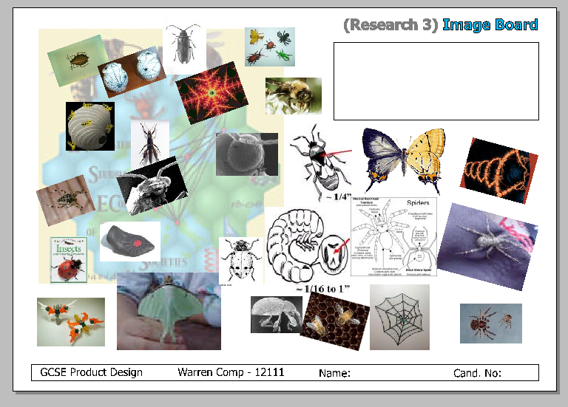
Later, you will be looking at this sheet again when you start to sketch your INITIAL IDEAS.
⇧

